More Practice With Writing Methods

For each of the following, write the method(s) indicated and then write a main method to call and test the method(s).

1. perfectSquare(int n) should return true if its non-negative integer parameter is a perfect square (e.g. 16, 64, 225, etc.); otherwise it should return false.
2. mySubstring(String s, int start, int end) and mySubstring(String s, int start) should do the same things as the String class methods substring(int start, int end) and substring(int start) respectively, but pass the string as a parameter as well. There should be only one main method used to test these overloaded methods. Do not use substring(int start, int end) and substring(int start) in your code.
3. myIndexOf(String s, String, str) and myLastIndexOf(String s, String str) should do the same things as the String class methods indexOf(String str) and lastIndexOf(String str) respectively, but pass the string as a parameter as well. Do not use indexOf(String str) and lastIndexOf(String str) in your code.
4a. numberOfDays(int month) should return the number of days in month. For example, if month has the value 2, then 28 should be returned since there are 28 days in February. Don’t worry about leap years.
b. leapYear(int year) should return true if year is a leap year; otherwise, it should return false. A year is usually a leap year if its number is a multiple of four. It is not a leap year, however, if its number is a multiple of 100 but not a multiple of 400.
c. dayNumber(int year, int month, int day) should return the number of days in a year up to and including the current day. If the value of any parameter is invalid, then dayNumber should print a warning message and return the value 0. Accept any non-negative year as being valid. Use numberOfDays from part (a) to find the number of days in any given month and leapYear in part (b) to determine whether the year is a leap year or not. This table gives some examples of the action of the dayNumber method:

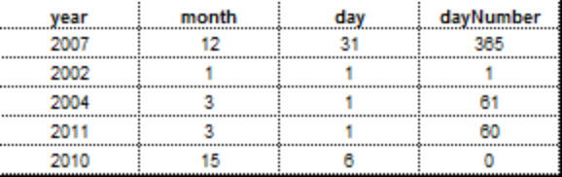

5. pascalTriangle(int n) should output Pascal’s Triangle up to n rows, where n is a positive integer parameter. The user should enter the value for n (between 1 and 8 inclusively) in the main method. Each number in Pascal’s triangle is obtained by adding the two numbers (one to its left and one to its right) in the row above. For example, if n = 7, then pascalTriangle should output this:

1
1 1
1 2 1
1 3 3 1
1 4 6 4 1
1 5 10 10 5 1
1 6 15 20 15 6 1

6. reverse(String s) should return a string whose value is the reverse of s. For example, if s is desserts, then reverse should return stressed.
7. sameReverse(String s) should return true if the value of s and the “reversed” value of s are the same; otherwise, it should return false. Hint: use the above reverse method.
8. square(int n) and square(int n, char c) should output an n X n “square” of the character @ or an n X n “square” of the character in parameter c respectively. For example, the call square(2) should output @@
@@
And the call square(3, ‘&’) should output &&&
&&&
&&&
There should be only one main method used to test these overloaded methods.

9. noVowels(String s) should return a string whose value is the same as the value in s but without vowels. For example, if s is DAVID wears glasses., then noVowels should return DVD wrs glsss..
10. capitalOnly(String s) should return a string whose value is the same as the value in s but with capital letters only. For example, if s is EVAN Z. Must Wear Glasses!, then capitalOnly should return EVANZMWG.
11. notLetter(char c) should return true if c is not a letter; otherwise it should return false. The method should contain exactly one statement in its body.

